Name:**BOYA DRAVEEN KUMAR**

Trainer Name:**HARSHEE PITRODA**

Batch Number: G-15

Course Name: **Mechainlearning With Python**

Date:**31-May-2022**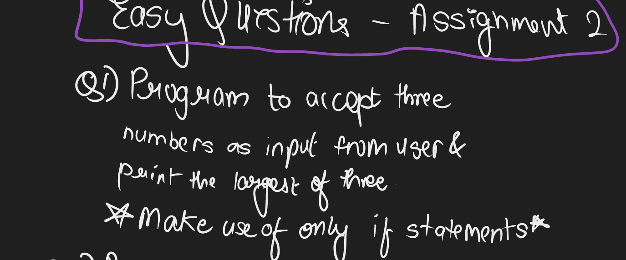

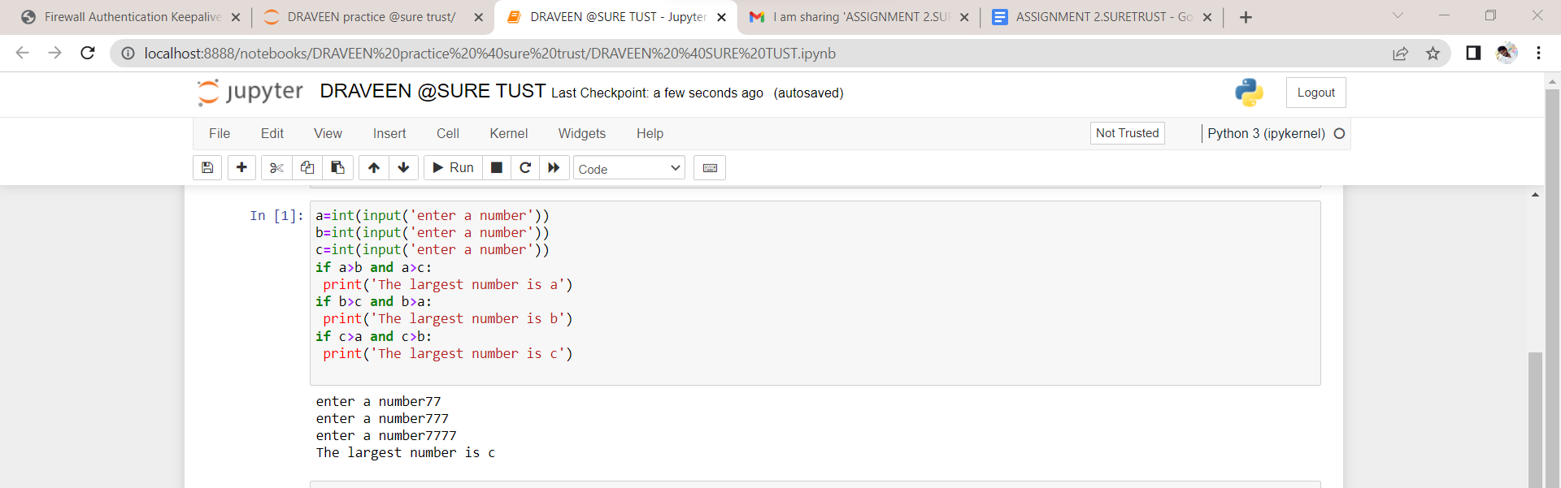

a=int(input('enter a number'))

b=int(input('enter a number'))

c=int(input('enter a number'))

if a>b and a>c:

print('The largest number is a')

if b>c and b>a:

print('The largest number is b')

if c>a and c>b:

print('The largest number is c')

Sample input: enter a number77

enter a number777

enter a number7777

Sample output: The largest number is c

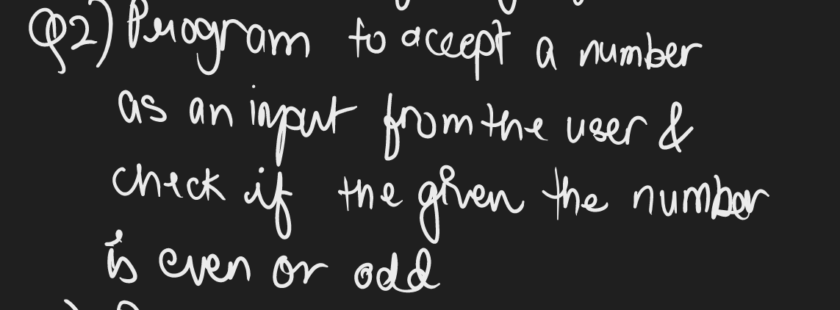

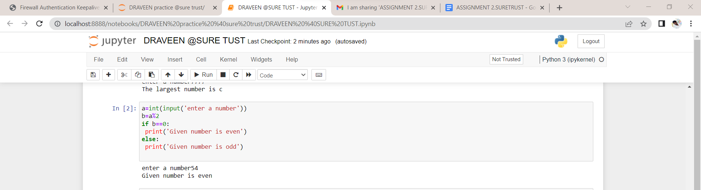

a=int(input('enter a number'))

b=a%2

if b==0:

print('Given number is even')

else:

print('Given number is odd')

Smaple input:

enter a number54

Sample output:

Given number is even

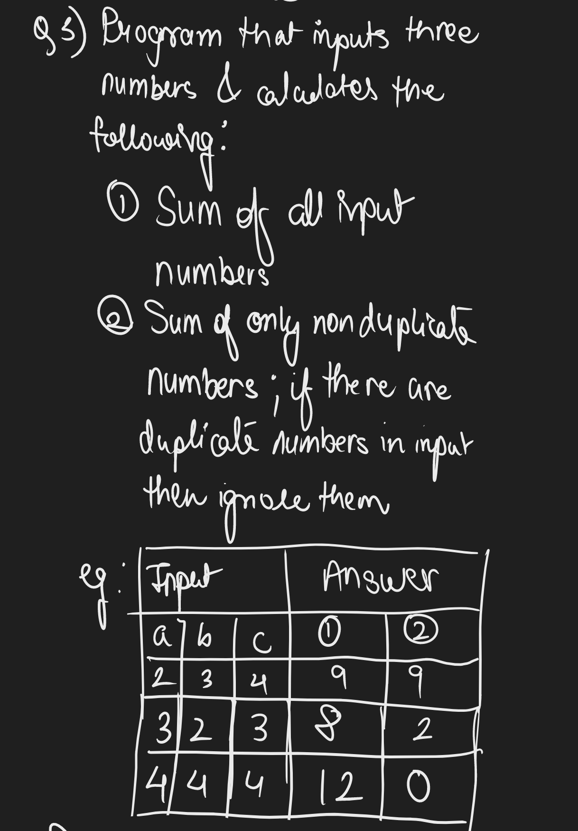

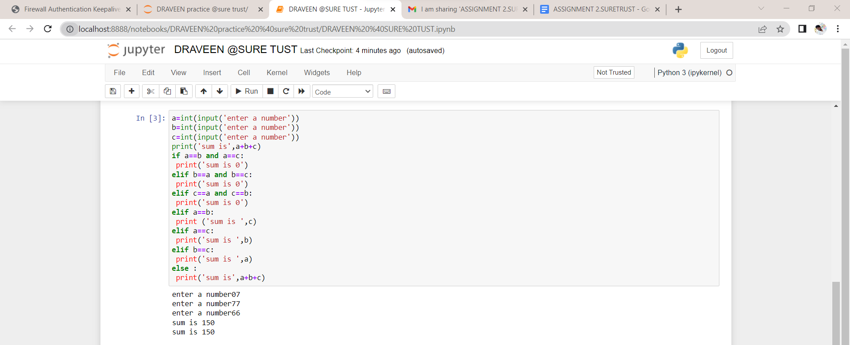  
a=int(input('enter a number'))

b=int(input('enter a number'))

c=int(input('enter a number'))

print('sum is',a+b+c)

if a==b and a==c:

print('sum is 0')

elif b==a and b==c:

print('sum is 0')

elif c==a and c==b:

print('sum is 0')

elif a==b:

print ('sum is ',c)

elif a==c:

print('sum is ',b)

elif b==c:

print('sum is ',a)

else :

print('sum is',a+b+c)

sample input:

enter a number07

enter a number77

enter a number66

Sample output:

sum is 150

sum is 150

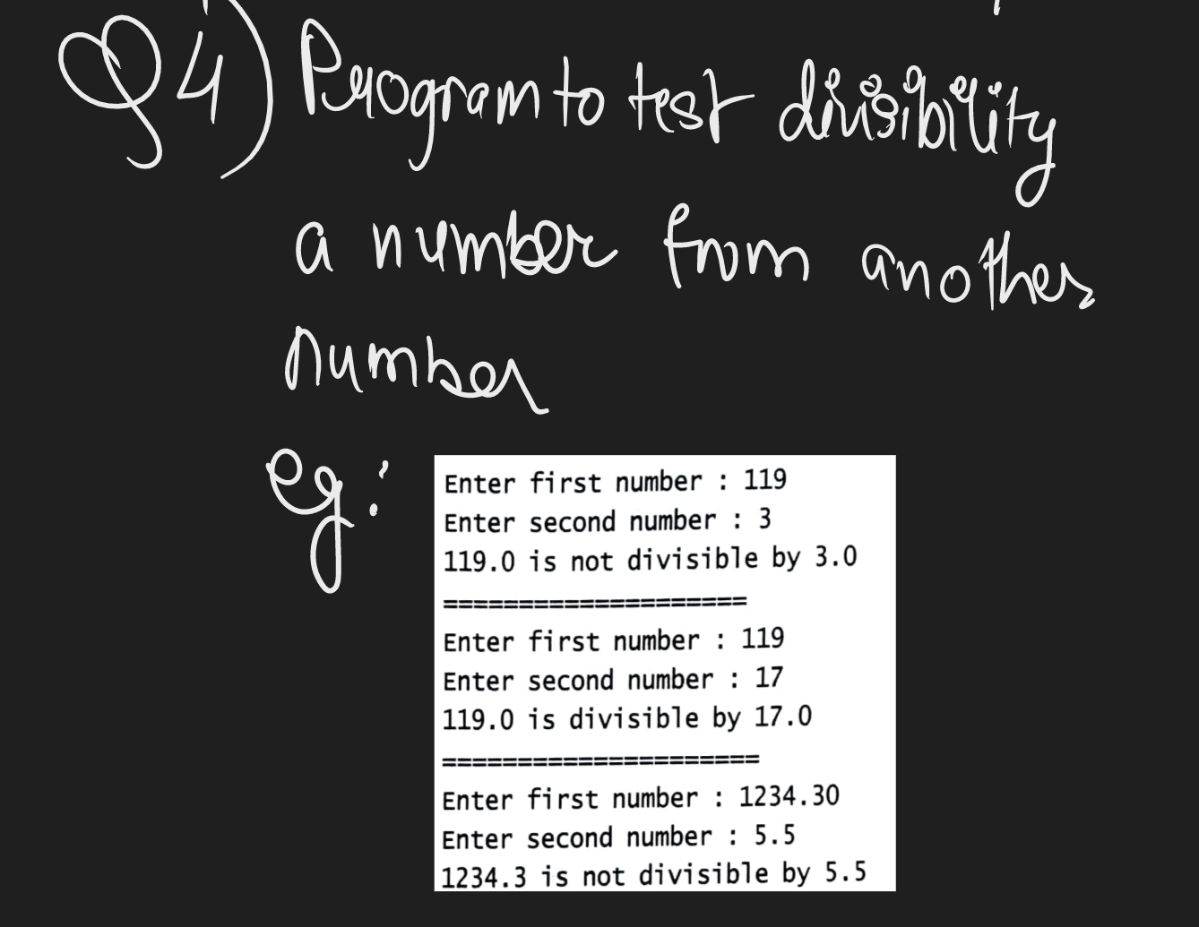

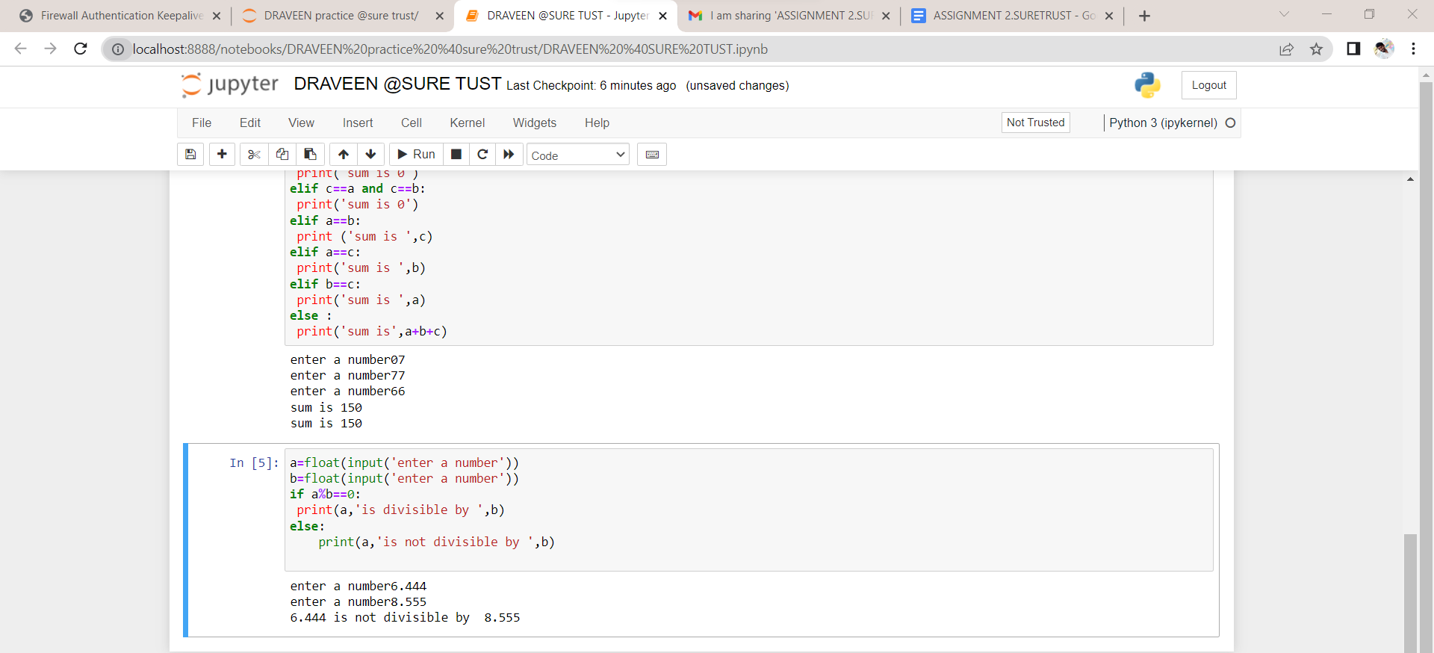

a=float(input('enter a number'))

b=float(input('enter a number'))

if a%b==0:

print(a,'is divisible by ',b)

else:

print(a,'is not divisible by ',b)

Sample input:

enter a number6.444

enter a number8.555

Sample output:

6.444 is not divisible by 8.555